**Subject: Software Construction and Development (Practical)**

**(Lab 1 - Tasks Solution)**



|  |  |
| --- | --- |
| **Roll No** | **22SW040** |
| **Section** | **One** |
| **Name** | **Farooque Sajjad** |
| **Teacher** | **Ma’am Hina** |

**LAB 01 TASKS**

**NOTE: THE DIAGRAMS ARE CREATED WITH A WEB APP NAMED LUCIDCHART (An online platform)**

**Task 1**

Your first task is to analyze both examples and write scenarios. You must use appropriate Class Diagram Terms in your statements by understanding the meaning for each symbol drawn in the example.

***Example 1***

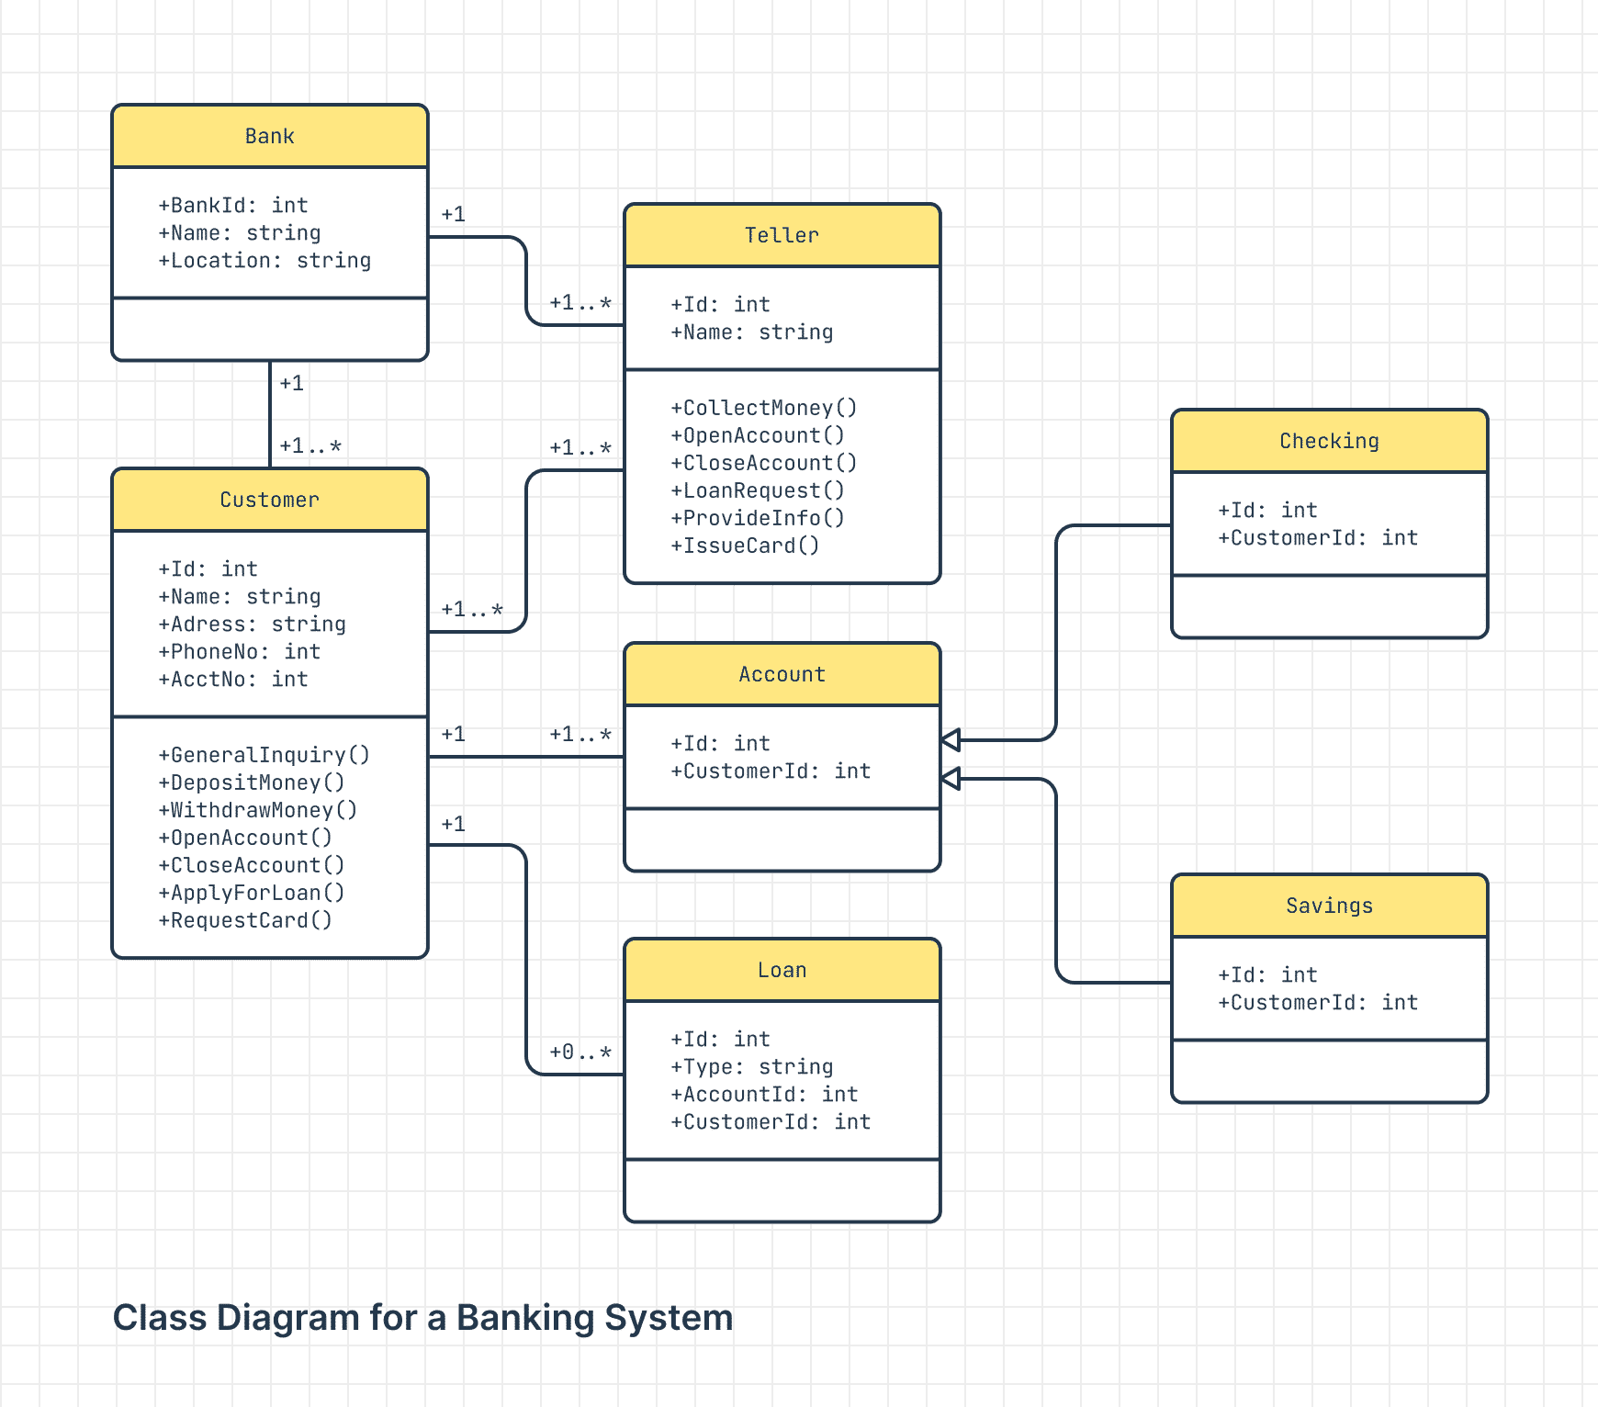

***1. Bank scenario***

The bank is like the main hub where everything happens. It has:

* A Bank ID, a unique number for each bank.
* A Name, like "XYZ Bank."
* A Location, telling where the bank is.

The bank works with:

* Customers (people who use the bank’s services).
* Tellers (staff who interact with customers and perform tasks like creating accounts and collecting money).

The bank can manage many customers and many tellers.

2. Customer Details

A Customer is someone who uses the bank to manage money or take loans. Every customer has:

* An ID to identify them uniquely.
* Their Name, Address, and Phone Number for contact.
* An Account Number for their bank account.

What can a customer do?

* Deposit Money: Put money into their account.
* Withdraw Money: Take money out of their account.
* Apply for a Loan: Request money from the bank that they’ll repay later.
* Request a Card: Ask for a debit or credit card.

3. Teller Details

A Teller is like a bank employee who helps customers. They can:

* Collect Money: Accept cash or checks from customers.
* Open an Account: Help create a new bank account for a customer.
* Close an Account: Shut down an account if a customer doesn’t need it anymore.
* Process Loan Requests: Handle loan applications and link them to the customer.

4. Accounts Overview

The Account class represents a general type of bank account. Every account has:

* An ID to uniquely identify it.
* A Customer ID to show who owns the account.

There are two types of accounts that inherit (or are specialized versions of) the general Account:

1. Checking Account: Used for daily transactions, like paying bills or shopping.
2. Savings Account: Used to save money, often earning interest over time.

This means Checking and Savings accounts share the same basic features of the Account class but also have some unique behaviours.

5. Loans

The Loan class handles everything related to loans. A loan is:

* Linked to a Customer (the person taking the loan).
* Linked to an Account (where the loan money might be deposited).
* Identified by a unique Loan ID.
* Categorized by a Type, like "Home Loan" or "Car Loan."

Special Rule for Loans:

Loans have a composition relationship with the Customer:

* If the Customer is deleted (e.g., they stop being a bank customer), their loans are also deleted automatically because a loan cannot exist without the person who took it.

6. Relationships Between the Classes

Let’s simplify the relationships:

1. Bank and Customers:
   * The bank manages many customers.
   * Customers are connected to the bank through their accounts and loans.
2. Bank and Tellers:
   * The bank employs many tellers.
   * Tellers handle customer requests like opening accounts or processing loans.
3. Account Inheritance:
   * Checking and Savings accounts inherit common features from the general Account class.
   * This means they are specific types of Accounts with some shared and some unique features.
4. Loan Composition:
   * A loan is tightly linked to the customer.
   * If the customer is removed, their loans are also removed.

Example of How It Works

Imagine John walks into a bank:

1. He meets the teller and says he wants to open a Savings Account.
2. The teller uses the bank system to create an account for John, giving it a unique Account ID and linking it to John’s Customer ID.
3. John deposits money into his account (the teller processes this as a transaction).
4. Later, John applies for a loan (like a car loan). A Loan ID is created and linked to John’s account and customer details.
5. If John ever closes his bank relationship (e.g., he moves to another country and deletes his account), the bank automatically deletes his loans because they are linked directly to him**.**

**Example 2**

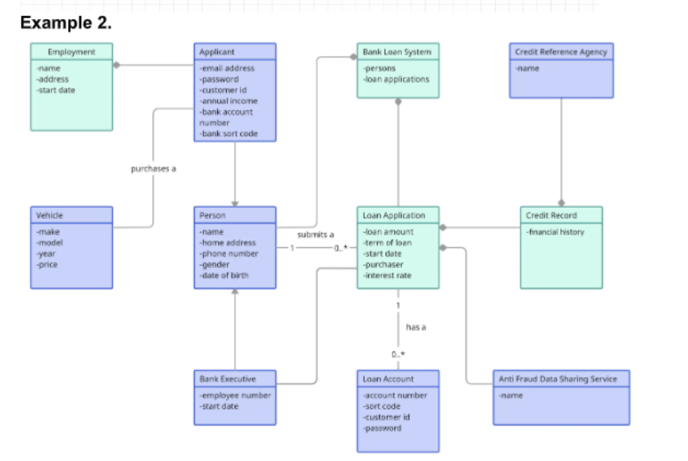

1. Person and Applicant (Inheritance) Scenario:
   * A Person has basic details like name, address, phone, gender, and date of birth.
   * An Applicant is a type of Person but with extra details like email, password, income, and bank account info. This is an "is-a" relationship (Applicant is a Person).
2. Loan Application (Association):
   * A Loan Application is linked to a Person because it holds details like the loan amount, term, start date, and interest rate. The application is associated with the Person applying for the loan.
3. Bank Loan System (Aggregation):
   * The Bank Loan System manages many Loan Applications and People. It connects to them in a way that shows they can exist independently of the system (aggregation). This is shown by a hollow diamond symbol.
4. Loan Account (Dependency):
   * A Loan Account is created after a loan is approved. It depends on the Loan Application for its details (like account number and customer ID) and interacts with an external Anti-Fraud Data Sharing Service for fraud checks.
5. Employment and Vehicle (Simple Association):
   * An Applicant may provide details about their job (like address and start date) and their vehicle (like make, model, year, and price). These details are linked to the Applicant through a simple connection.
6. Credit Record and Credit Reference Agency (Association):
   * A Credit Record holds the Applicant’s financial history. It is linked to the Loan Application and interacts with a Credit Reference Agency to check the Applicant’s financial status.

Key Symbols:

* Inheritance (Triangle): Applicant is a type of Person.
* Association (Solid Line): Simple connection between classes, like Applicant to Employment.
* Aggregation (Hollow Diamond): Bank Loan System Groups Loan Applications and Persons but doesn’t own them.
* Dependency (Dashed Arrow): Loan Account relies on external services like the Anti-Fraud Data Sharing Service.

TASK 02



